NEWSLETTER AND EVENTS FOR FEBRUARY 2022
The Hub Winter Opening Hours are:
Monday/Tuesday: Hub CLOSED, Wednesday: Events ONLY,
Thursday/Friday: Events, Hot Drink/Cakes from the SHOP 11-2pm.
Saturday: Café 10am – 4pm Shop 11am – 2pm
Sunday: Café 10-6pm. (Hot food till 3pm) Shop: 11am – 2pm
Call 01387373760 or email hub@eskdalemuir.com
Events Information
Wednesday: Paint Aid, Weekly 1.30 - 3.30pm. All welcome. FOC/Donation for the room.
Thursday : Writers Group 11-1pm. Every other week, all welcome. FOC/Donation for the room.
Thursday: Hanna Casement Yoga Classes 1.30-3pm. are £8 and places are limited, so advance booking and payment is essential. Book directly with at hanna.casement@googlemail.com or www.facebook.com/hannacasementyoga
Friday: Tai Chi. 10.30–11.30am with Angela & Graham Barrie. £30 for 4 sessions. All welcome including beginners.
Friday Pool & a Pint 7.30 – 11pm. Every Friday.
Sunday: Church Service of Worship 13th February and 13th March 2022 3pm.
Friday 18th February. 7.30pm Jilly jazz improv: Singing Workshop with Jilly Jarman. We sing songs, play around with rhythms and grooves, experiment with harmonies and words and explore different ways of using our voices. A lot of fun no experience necessary! The bar will be open for refreshments. £7.50 per session.
Bowling at the ESMP Hall 7pm on the first and third Friday of each month. Come have a go, it’s good fun.
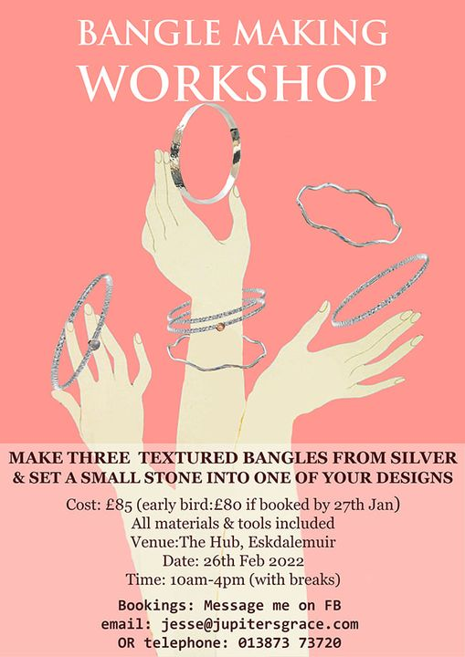
Jewellery Making Workshops with Jesse, 5th February 10 – 4pm. Making silver Earrings – FULLY BOOKED.
Bangle Making with Jesse - Saturday 26th February 10am-4pm. 6 places available. Make three textured bangles & set a small stone into one of your designs. No experience necessary - all tools and materials provided.
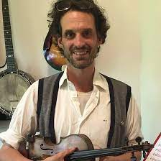
Open Music Sessions on the First Sunday of the Month starting 6th February at 2.30pm with Nick Jenkins and Angelo. Please bring your instruments, your voice and tell your friends, it is going to be such a great musical afternoon. Open to all. Bar open till 6.30pm.

Everyday Mindfulness and Meditation Taster Saturday 12th 11am – 1pm by Angie Ball FREE
taster session. Come and find out more.
Everyday Mindfulness and Meditation Course
SATURDAY 19th February 10am – 4.30pm Full day workshop. Including helpful practices for everyday life. Talks, discussions and sitting sessions. Wednesday 23rd February, 2nd ,9th and 16th March – 5.30 – 7pm and SATURDAY 12th March 10.30 – 4.30pm Full day retreat. Full Course at a reduced rate of £100
BOOKING ESSENTIAL 01387373386
Suggested home practices in-between sessions and please bring a firm cushion and blanket or yoga mat to these sessions

Please respond with remove if you no longer wish to receive mailings from us.
UEDG is a Company Limited by Guarantee, Co. No. SC306741 & Scottish Charity No. SCO43890
Lunch ‘Meet and Eat’ Club - 3rd March for Losar – to celebrate Tibetan New Year. Sorry no lunch in February. We need volunteers to make this event happen. If you would be interested to be on the rota please get in touch. Please book at 013873 73231 or hub@eskdalemuir.com
Defibrillator Training 1.30pm Saturday 5th February – This will take half and hour and could save a life, please come and find out how to use the Defibrillator which is located on the outside of the Hub.
Treatment Room
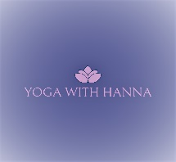
Friday is Feel Fantastic day at the Hub. We have two beautiful different massage treatments on offer on Fridays. Fantastic at enhancing a feeling of deep relaxation and wellbeing.
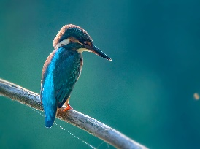
Hanna Casement is offering Ayurvedic facial rejuvenation massage treatment, £35 for a full hour. Appointments must be booked at least 48 hours in advance with Hanna, hanna.casement@googlemail.com Treatments will be between 10am and 4pm on alternate Fridays.
Kirsten Jenkins is offering sessions of seated Shiatsu and can combine this with Indian Head Massage treatment. £25 for 40 minutes. To book contact Kirsten direct on 07852595750 or www.facebook.com/KirstenShiatsu
The Exhibition Hall
We still have the successful exhibition of Paintings by June Utting, so please pop in and see her lovely work. We are looking for more artists to exhibit in the lovely hall. If you would like to exhibit, then please get in touch.
Membership and Volunteering
It is that time of year again for folk to re subscribe their membership of £1. We have full membership for those living in the parish and associate membership for those out with. So, if you love the Hub and want to ensure it is still here in years to come, get involved and join us in making the Hub buzz. We have some great ideas and activities on the horizon, but we cannot do them without you! If you are not a volunteer or member, please tell us why. We need to know what/why you do not want to be involved. The Hub is an amazing asset to the Valley, if it is not performing as you want, then let’s have that discussion. This is your Hub. You can shape it and you can help make it great!
Volunteers are needed to: manage/serve in the bar, the shop, to wash up/serve in the café, to welcome visitors, to help with events. We can match you to jobs you like when you like. Everyone is welcome, please get in touch!
Sale or Swap Shop – Upstairs @ the Hub
We are starting a nearly new Sale or Swap Shop upstairs in room 18. It is open when the Hub is open and we are encouraging everyone to go and have a look and buy or swap. Recycling in the valley is good for our bank balances and even better on the environment. Come for a rummage, there are lots of lovely, preloved items, from clothing, plants, seeds, household items. If you see something you would like, either put a donation in the box, or bring in a nearly new item you no longer need next time you visit. Volunteers who would like to get involved such as helping to sort, upcycle and make items reusable, please get in touch.
Save the Dates
It is the year of the LEL – London Edinburgh London bike ride. The Hub will again be hosting, for three days, for around 1000 cyclists. We need many volunteers and helpers to make it a success. It is an amazing atmosphere and great experience suitable for everyone to help. Please keep the 9th – 11th August free! We are hosting DGArts Festivals live performance of Tickbox 7.30pm, 23rd May. More details to follow. The 2nd - 5th June we will be hosting local artists for Spring Fling, its going to be a fantastic weekend as we will also be having some lovely food to celebrate the Queen’s Platinum Jubilee.
Please respond with remove if you no longer wish to receive mailings from us.

