NEWSLETTER AND EVENTS FOR FEBRUARY 2022
The Hub Winter Opening Hours are:
Monday/Tuesday: Hub CLOSED, Wednesday: Events ONLY,
Thursday/Friday: Events, Hot Drink/Cakes from the SHOP 11-2pm.
Saturday: Café 10am – 4pm Shop 11am – 2pm
Sunday: Café 10-6pm. (Hot food till 3pm) Shop: 11am – 2pm
Call 01387373760 or email hub@eskdalemuir.com
Updated Events Information and Local Sales
‘Meet and Greet’ Lunch Club is not going to take place in February. Sorry, that was my error when typing up the February newsletter, the Diary pages for February are correct. We thought it would be nice for everyone to get together to celebrate Losar – Tibetan New Year on Thursday 3rd March instead. Volunteers to make this happen would be much appreciated. More information to come in the March Newsletter, but it will be a great lunch, so put it in your diaries!
Everyday Mindfulness and Meditation Course by Angie Ball
Saturday 12th February 11am – 1pm FREE taster session. Please note the change of date to originally advertised. BOOKING ESSENTIAL 01387373386
Introduction & proposed further sessions
Sitting practice - settling the busy mind
Getting to know each other
Initial discussions - Our needs/ wishes /what we would find most useful
If enough people wish to take part then the course will take place on the following dates.
TOTAL PRICE OF COURSE BELOW £100
payment in instalments with initial deposit of £50 can be arranged
SATURDAY 19th February 10am – 4.30pm
Full day workshop
Including helpful practices for everyday life
Talks, discussions and sitting sessions
Wednesday 23rd February 5.30 – 7pm
Wednesday 2nd , 9th and 16th March– 5.30 – 7pm
4 Practice sessions.
SATURDAY 19th March 10am– 4.30pm
Full day retreat.
Suggested home practices in-between sessions and please bring a firm cushion and blanket or yoga mat to these sessions
What do we mean by Mindfulness? Mind Full-ness! Well, it’s often pretty full isn’t it? Full of all kinds of useful and useless information – never ceasing – on and on and on…. So, what can we do about it? Well, the first answer is – absolutely nothing!! That’s maybe a bit of a surprising answer, but in some kind of way, that’s it – but maybe not quite as simple as it sounds.

Absolutely nothing – actually means – firstly being aware of what’s happening both in our minds as well as externally in each moment that it is happening- when its happening – no matter what it is – yet without acting or reacting recognising the endless flow of thoughts, emotions, feelings, and, holding it all in a wider sense of awareness with no particular agenda. Secondly, by realising how unsettled our minds generally are, training our minds to settle, whilst developing an attitude of acceptance, kindness, and curiosity towards each moment of our experience. If you are interested in learning more of the fundamentals of Mindfulness meditation, this course is an introductory to the initial steps to firstly recognise the busy mind and learning ways to help the mind to settle.

Surprisingly, contrary to many people’s belief of meditation and mindfulness, the aim is not particularly or only to have a peaceful mind. Yet, the possibility of more tranquillity can be a by-product! As the mind becomes more tranquil there is an opportunity to bring more awareness along with our kind curiosity to the habitual mind’s tendency of fixating on the past, present or future. Very soon we may begin to see that this does not necessarily bring us happiness, so with a bit of mind-training we are able to shift to an alternative focus and begin noticing how we get continually caught up in our habitual patterns believing them to be real, so constantly reinforcing the habit - which is not essentially our fault! So, our mind training gradually gives us a choice – to not necessarily constantly engage with our old stories!

This course will offer practices to help settle the mind, to look at the nature of distraction and practices to begin to let go of distraction. Introducing a useful model to help us understand where we get caught entitled the ‘Undercurrent and Observer’ and practices to develop further self-acceptance, kindness and integrating all practices through a deep sense of embodiment.

Local House Clearance
Please help find homes for some lovely bits of furniture, and household equipment. A local family has had to move away and so they are sadly having a house clearance.

They have clothes, bedding (some new still in packages), towels, tea towels, cutlery, pots and pans, crockery, beds, a great selection of books, ornaments, plant pots, plants in pots, and other useful things. Too good to throw away. If you would like to find out more then please get in touch directly with the person who is kindly dealing with the clearance on behalf of the family. Collection only. Needs to go ASAP - Tel: 013873 73242

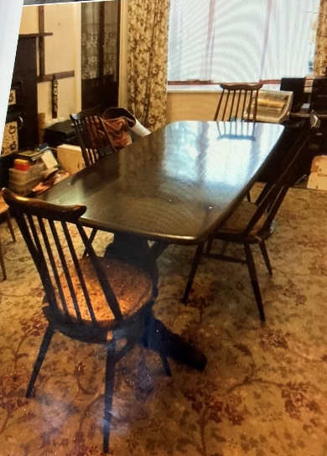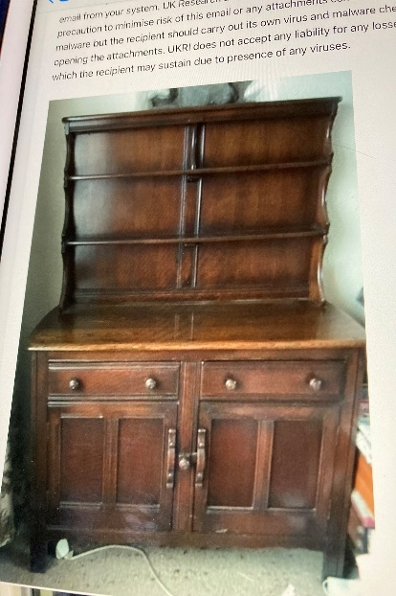
Ercol Dresser, Ercol rectangular Dining table and 4 chairs. All matching. Offers invited can go separately if required.

Please respond with remove if you no longer wish to receive mailings from us.
UEDG is a Company Limited by Guarantee, Co. No. SC306741 & Scottish Charity No. SCO43890

