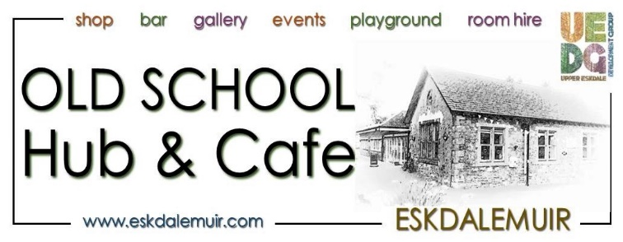
NEWSLETTER AND EVENTS FOR AUGUST 2022
The Hub Opening Hours are:
Café and Shop: Tuesday – Sunday, 10am – 4pm (Hot food till 3pm)
Bar: Friday 7.30pm -11pm Sunday Noon till 6.30pm
Call 01387373760 or email hub@eskdalemuir.com

OUR FABULOUS REGULAR ACTIVITIES – if you haven’t already, why not give them a go!

Writers Group Is postponed until mid September.

Yoga with Hanna Casement. Every Thursday: 1.30-3pm. £8 per class. Places are limited, so advance booking and payment is essential. To Book: hanna.casement@googlemail.com, or www.facebook.com/hannacasementyoga

Tai Chi Every Friday, 10.30–11.30am with Angela Barrie. £30 for 4 sessions. All welcome. To book, email Angela Graham-Barrie on creatinginnerrainbows@hotmail.co.uk

Pool & a Pint Every Friday: 7.30 – 11pm. All Welcome, even those who can’t play pool, or drink a pint!

From a Swap Shop to a Reading Room and Community Library

Due to lack of helpers, and the amount of un-swappable stock, we have decided to stop the Sale/Swap Shop. We have decided that it would be better to create a library and reading room upstairs, so that people can donate good quality books, DVDs, CDs and jigsaws. People can borrow them or sit and enjoy them upstairs with a cuppa from the café. If there is enough interest, we can start to build up a library of other things people need.

Our Treatment Room
We have two fabulous massage treatments on offer on Fridays. Fantastic at enhancing a feeling of deep relaxation and wellbeing. Hanna Casement is offering Ayurvedic facial rejuvenation massage treatment, £35 for a full hour. Appointments must be booked at least 48 hours in advance with Hanna, hanna.casement@googlemail.com Treatments will be between 10am and 4pm on alternate Fridays. 12th August, 26th August, 9th Sept
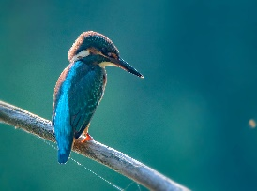
Kirsten Jenkins is offering sessions of seated Shiatsu and can combine this with Indian Head Massage treatment. £25 for 40 minutes. To book contact Kirsten direct on 07852595750 or www.facebook.com/KirstenShiatsu 5th August, 19th August, 2nd Sept
Diana Stewart Foot Care. Excellent for all your foot care needs. Corns, hard skin, nail dianajstewart@gmail.com.

PLANT SALE
We have a table in the Exhibition Hall with plants and seeds and all things gardening related. Please bring your plants along and have a look at what is on offer. We have a donation box for the HUB to raise some funds for a generator for winter.

Reading Room

We are soon to create a cosy and inviting reading room upstairs in The Hub. If anyone knows of the Danish word ‘Hygge’ (as seen in picture below), this is the atmosphere we are going for! Please donate any good quality books, CDs and DVDs. You can borrow them, or sit and enjoy them with a cuppa!
All welcome!

Hygge: “A quality of cosiness and comfortable conviviality that engenders a feeling of contentment or well-being”

WANTED
We would like to find out if anyone had an unwanted IPAD for us to use on the tills, as ours are too old. We are also looking for a laptop if anyone has one that they no longer need.

EV Chargers
The Hub is excited to be having electric vehicle charging points, for both electric vehicles, and electric bikes, installed on 15th August, available for any customers and visitors to use.

Lunches
We are no longer doing roast dinners on a Sunday. We will have other ‘specials’ which will be advertised on our facebook page

HUB KITCHEN GARDEN CLUB
We are going to create raised beds so we can grow some of our own vegetables and fruit for the local community and our kitchen. Come and help build a more sustainable HUB, if you have time, seeds, plants, enthusiasm pop along. We might even get a chance to make some preserves and pickles.

August Events

We are taking part in the Vodafone UK’s everyone connected initiative, tackling the digital divide in the UK.
We are distributing free Vodaphone sims, which are available to everyone on the reception desk at the hub.

What is our everyone connected campaign?
We believe connectivity is essential, and everyone should have access to the opportunities it provides. We have put tackling the digital divide at the heart of our business and we'll continue to champion the issue until it no longer exists.
To help tackle the digital divide, we want to connect 1 million people by the end of 2022. We’re working with charity partners, our customers and employees to give digital access and skills to the most vulnerable people in our society. We champion this issue to raise awareness, and we give people ways to get involved through our initiatives like the Great British Tech Appeal and Buy One Give One.

Dinner and Quiz Night Saturday 30th July 7pm
There will be a Mexican themed Dinner from 5.30pm, with Veggie or Meat options. £10 for dinner (you are welcome to come just for the dinner if you wish). BOOKING ESSENTIAL
7pm. £3 per head for Helens brilliant QUIZ. Four people per team. Don’t worry if you haven’t got a team. Come along as you are and we can arrange people into teams once everyone has arrived. That said, if you would like to come as a pre-arranged team, that’s also ok.

or let us know when you are free, everyone who has helped in the past have had a great time

Jewellery workshop 6th August 10am – 5pm
What looks to be an amazing, silver jewellery workshop with Jessie from Jupiters Grace. Please contact her for enquiries and booking. Jesse@jupitersgrace.com 01387373720
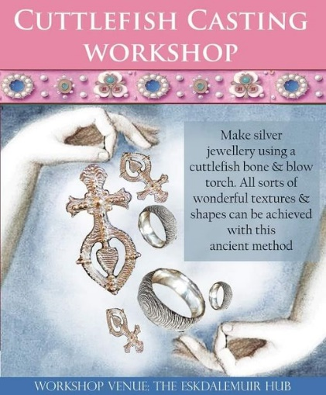

LEL Cycling Event – VOLUNTEERS ARE NEEDED!! 8TH – 11TH AUGUST
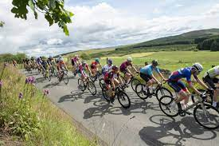
We will have around 1800 cyclists coming through between 8th and 11th August. We really need more volunteers to help for this event. So, if you can spare a few hours, please get in touch!
Volunteers needed to help cater for cycling events. London-Edinburgh . Please do get in touch with The Hub, or put put your name down in The Hub office. We also welcome people who just want to pop in on the day and help with whatever’s needed. The busiest times are likely to be from Tue morning through to Thur lunchtime

Singing class Friday 12th August and Friday 19th Sept, 7.30pm
Come to The Hub for some jazz improv singing class. £7.50 for 1.5 hours of singing and fun. All welcome.

Open Music Sessions 14th August 2.30pm
Open music sessions, with Nick Jenkins. Please bring your instrument, a song to sing, and tell your friends. This is going to be a great musical afternoon. Open to all. Come and tap your foot, dance or sing with these brilliant musicians. Bar open until 6pm.

Art Exhibition-Otherworldly Tales. All of August
In our exhibition halls this month we are delighted to host the works of Shen Chokyi and Catkin Van Hoppe, in their “other-wordly” exhibition. They are also both hosting open studios at their houses, as below.
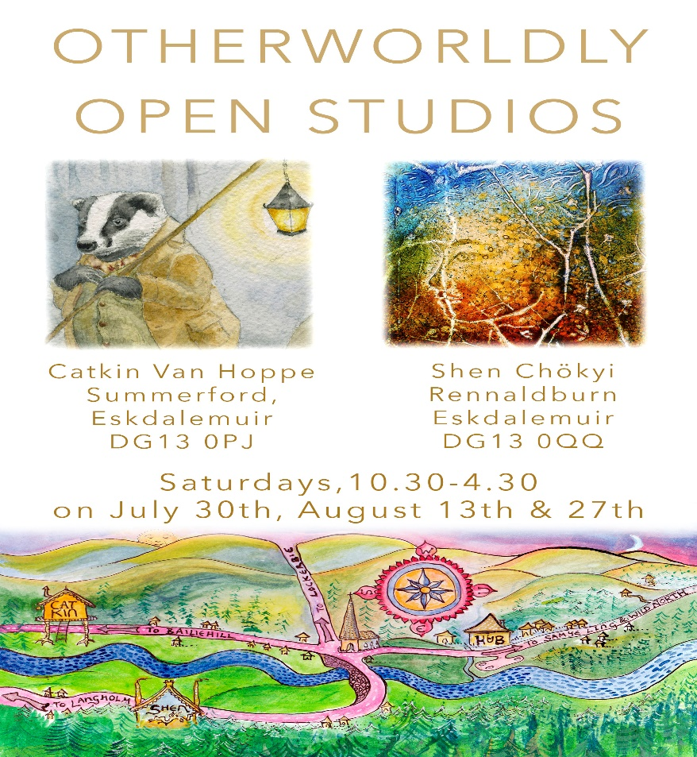

Cycling event Sunday 21st August 11am – 3 pm
Help Needed Please! There will be 300 cyclists potentially arriving at Tht Hub. We need some volunteers to help out please, so do get in touch if you can lend a hand.

Mobile Phone Photography September 3rd with Nicola Stead

Walking and Writing with Sukhema. September 24th

Hugh Bryden Exhibition for 6 weeks, starting beginning Sept.
From the beginning of September, The Hub is please to exhibit the works of Huhg Bryden. The exhibition will consist of paintings, prints, books and artist’s books.
Hugh Bryden grew up in Eastriggs and Annan, attended Eastriggs Primary School and Annan Academy, graduated from Edinburgh College of Art before returning to teach at Annan Academy then becoming Staff Tutor in Art with the Education Dept. Throughout his teaching career he exhibited prints and paintings in national and international exhibitions. In 2005 he took early retirement to concentrate on his artwork. He founded Roncadora Press to publish poetry pamphlets and artists books and has won major prizes for his books and artists prints. He has over the years been very involved locally painting murals and teaching workshops at various venues in Dumfries and Galloway

At the start of lockdown last year Hugh returned to painting after many years of printmaking and book publishing and began to produce small still life paintings using flowers from his garden alongside personal objects.
The Exhibition will feature a number of these paintings alongside artists original prints and hand- made artists books.
